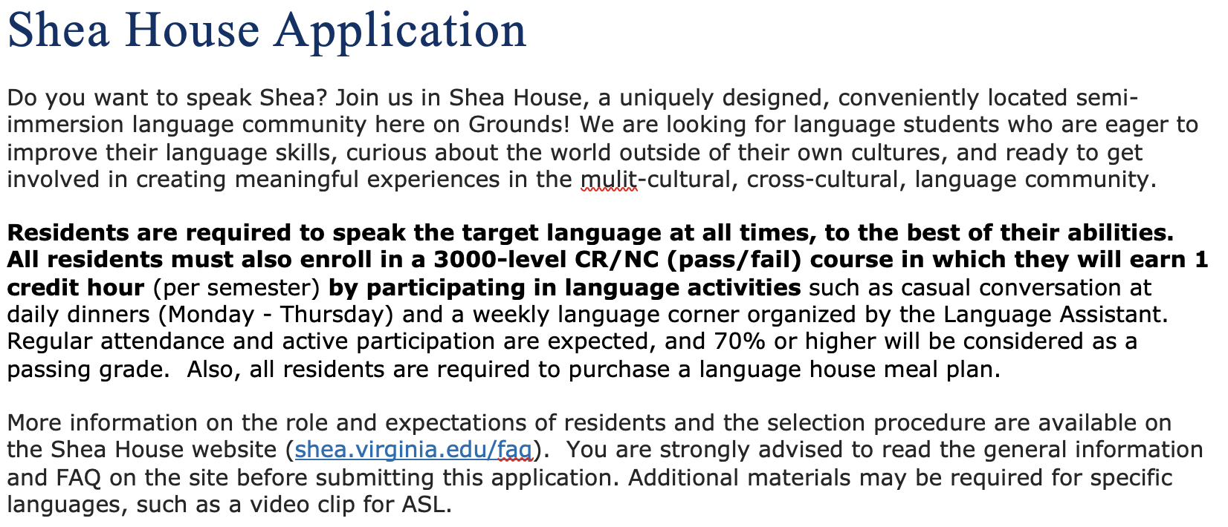

Applicant name (Last) __________(first)________ Gender:______ Current academic year: ______
Email: _______@virginia.edu

- Shea House language program to which you are applying (you may select only one):
Note: A minimum of 5 approved residents (4 residents and 1 Language Assistant) are required to form a language program.
- Please Select - American Sign Language Chinese German Korean Japanese Russian

- Academic Major/Minor (write intended major if undecided):
Note: Graduate students are not eligible to apply for residency in Shea House.

- Do you plan to study abroad during the 2024-25 academic year?
- Please Select - Fall Semester Spring Semester No plans to study abroad

- Will you be able to participate in basic conversation in the target language at the time you move into Shea House? At least one year of the formal language study at a college level is expected. (Applicants with a high proficiency level in the language are also eligible to apply.)
Please briefly describe your background in the language.
- List language courses you will (likely) be taking in the next academic year:
- Expected date of graduation:

- How would you contribute to the Shea House community if you are selected to live there? (250-300 words in English)

- If you have a preferred roommate who is also applying for the same language, please indicate his or her name and Computing ID below.
Note: All applicants will be expected to accept a single or a double room. Neither Housing & Residence Life nor the language departments will keep a waiting list for single rooms.

Email the complete (Late) application to Shea House faculty representative of the language program you are applying for or Email sheahouseofficial@gmail.com

